## **TABLE OF CONTENTS**

|  |  |  |
| --- | --- | --- |
| **S. NO.** | **TITLE** | **PAGE NO.** |
| 1. | Strategy and Justification  1.1. View on the Market  1.2. Justification for View  1.3. Strategy Used | 1 |
| 2. | Daily Tracking P&L and Strategy Evaluation | 8 |
| 3. | NSE Website Option Chain Screenshots | 10 |

**Chapter 1**

**Strategy and Justification**

**1.1. View on the Market**

Our view for the market according to technical and fundamental analysis is that the broader financial market will move sideways to moderately bearish.

**1.2. Justification for View**

1. **February 2024: Analysts were of the view that the recent rally in the stock market has left the three indices** - Nifty 50, Nifty Midcap 100 and Nifty Small-Cap 100 - overvalued. They delivered a return of 22%, 56% and 66% respectively in the past 1 year. The suggestions were for the investors to be cautious and be more selective.

Source: Live Mint article dated 19 Feb 2024

<https://www.livemint.com/market/stock-market-news/nifty-50-midcap-smallcap-indices-most-sectors-overvalued-says-hdfc-securities-advocates-bottom-up-stock-picking-11708316849624.html>

1. February 2024 - **SEBI asked money managers in a meeting to consider restricting one-off investments in small- and mid-cap stock** **mutual funds** from clients and cut commissions offered for their sale. Source: Reuters article dated Feb 29, 2024

<https://www.reuters.com/world/india/india-regulator-moves-curb-inflows-into-small-mid-cap-funds-sources-2024-02-29/>

1. **11 Mar, 2024, SEBI expressed concerns regarding irrational exuberance in small and mid cap**: SEBI chairperson Madhabi Puri Buch flagged about the bubble created in the small and mid cap, and suggested Mutual Fund trustees to look whether lumpsum investments in related funds are appropriate.

Relation with Nifty 50: Decline in the small and mid-cap segments can create a sense of risk in investors of other categories as well. This can turn into a domino effect from the worries about the overall market downturn. Along with this, markets are interconnected, investors may try to balance their portfolios, initiating a selling. In general, this creates a negative sentiment amongst the investors, especially unaware and less knowledgeable retail investors.

Source: News articles

<https://www.thehindu.com/business/markets/sebi-flags-froth-in-small-mid-cap-stocks/article67938275.ece>

<https://www.reuters.com/markets/asia/india-markets-regulator-flags-froth-small-mid-cap-stocks-2024-03-11/>

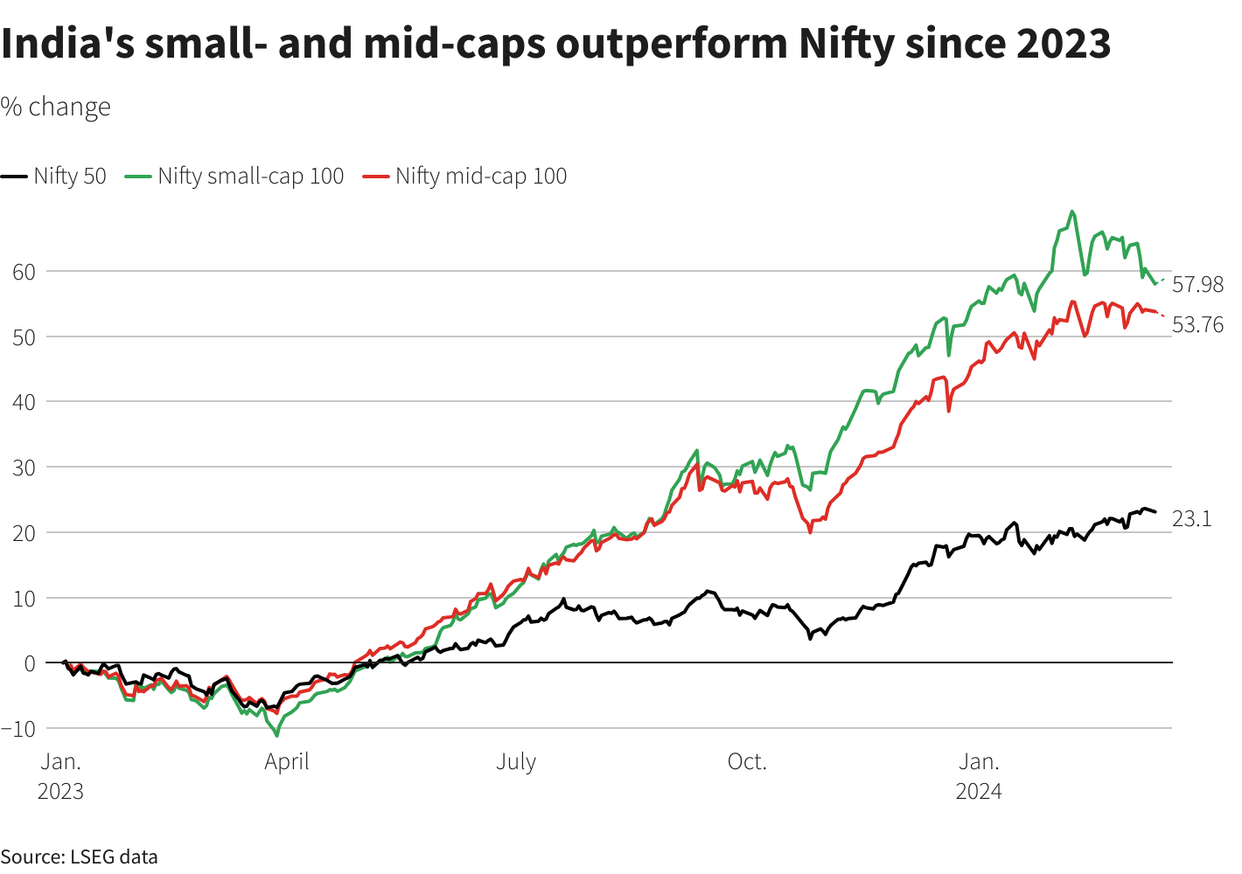

1. **February 1, 2024, FED, not confident about inflation control**- FED said that they are not yet ready to cut the rates as they are not confident about the control of inflation. The rates were intact in the meeting.

Source: Hindustan Times article dated Feb 1, 2024

<https://www.hindustantimes.com/world-news/us-news/us-fed-meeting-2024-live-fed-keeps-interest-rates-steady-as-powell-says-path-forward-is-still-uncertain-101706711894550.html>

Also, the Annual inflation rate in the US unexpectedly edged up to 3.2% in February 2024, compared to 3.1% in January and above forecasts of 3.1%.

Source: <https://tradingeconomics.com/united-states/inflation-cpi>

Implications: Higher rates in the US would restrict the inflow of money to the equity markets and to the markets of India.

1. **Profit booking and Financial year-end effect**: The month of March experiences the financial year closing. The stock market experiences profit booking for tax purposes, leading to a slight decline in the last month of the year, and a slight surge in the first month of the year.
2. **FIIs and DIIs were net sellers of Nifty futures and options**

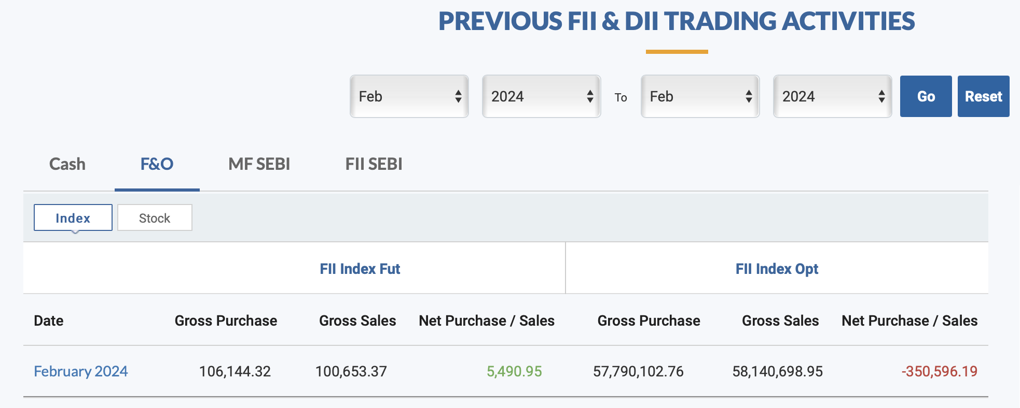

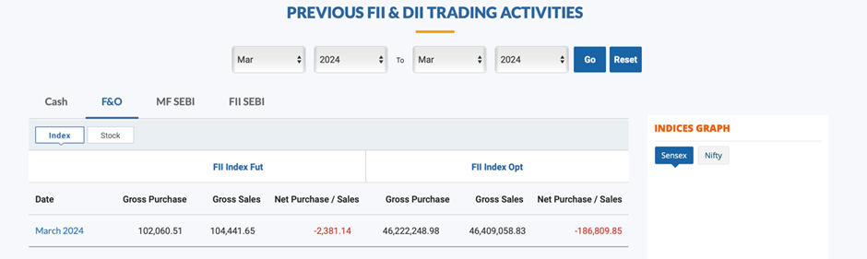

FII stands for Foreign Institutional Investors and DII stands for Domestic Institutional Investors. The table shows the gross purchase and gross sales figures for both FIIs and DIIs in the cash, F&O, MF, and SEBI segments. The table also shows the net purchase/sales figures, which is the difference between the gross purchase and gross sales figures.

FIIs and DIIs were net sellers of Nifty futures and options in March 2024, with a net sale of Rs 186,809.85 and Rs 2381.14 crore. This suggests that FIIs were bearish on the Nifty during that time period.

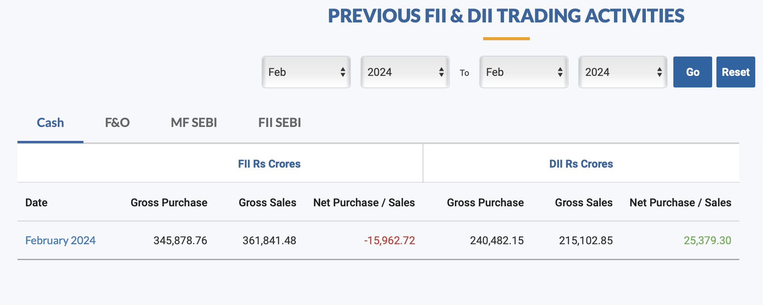

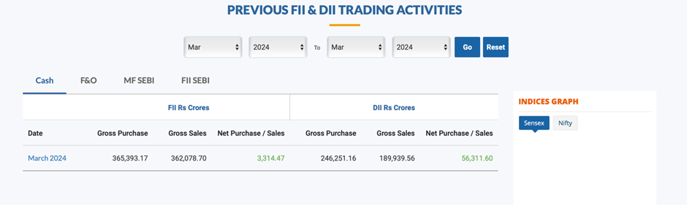

In the Cash segment however FIIs and DIIs have positive net purchases which could be buy on dips contra strategy and thus consolidation to bearish trend could be seen in the month of March.

**Technical Analysis -**

Weekly Timeframe

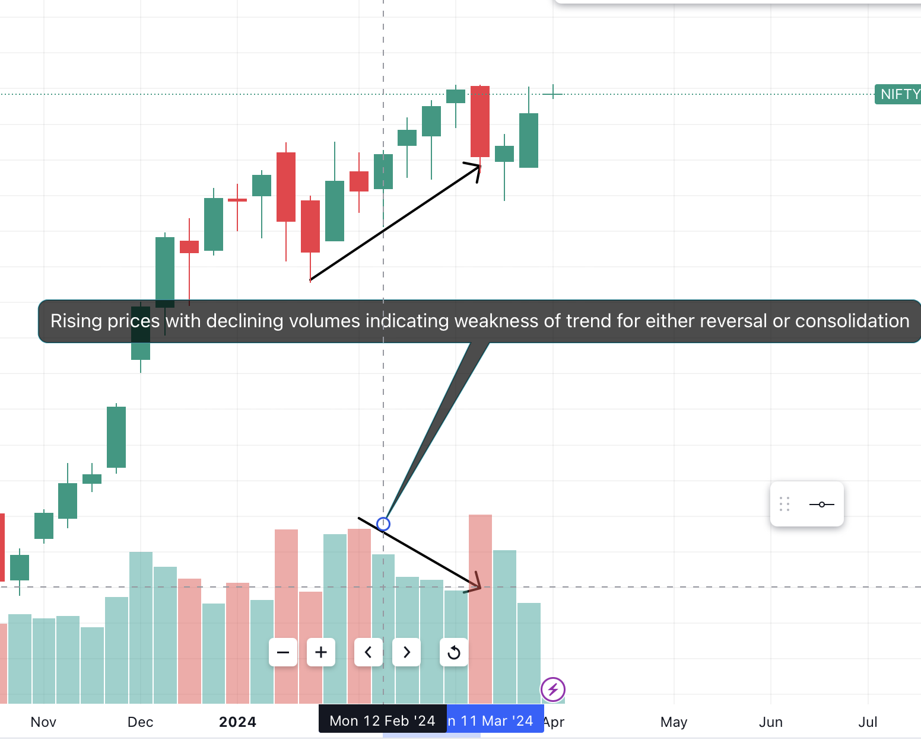

Rising prices typically indicate an uptrend, while declining volumes can signal a weakening of that trend. This could be a **sign that the uptrend is losing momentum** and could be due to a decrease in buying pressure.

There are two possible continuations for this price movement:

* Reversal: The price could start to trend downwards, indicating a change in sentiment.
* Consolidation: The price could move sideways within a range, as buyers and sellers reach an impasse.

Daily Timeframe -

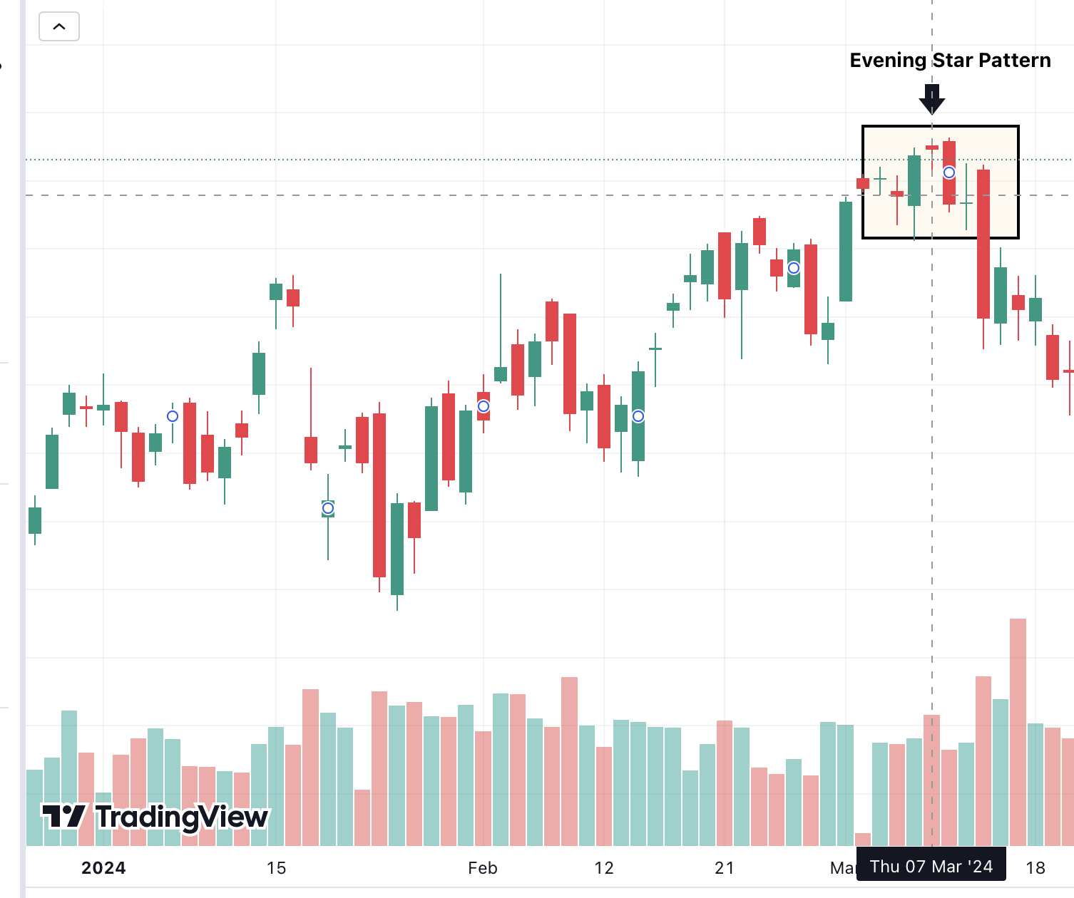

In the daily timeframe, **the evening star bearish reversal pattern is noticed**, which typically forms at the end of an uptrend and signals a potential decline in price.

Below is a breakdown of the evening star pattern:

* The first candlestick (tall green candle) represents a strong rally during the day.
* The second candlestick (small-bodied doji) opens higher than the first candlestick but closes near its opening price, indicating indecision among buyers and sellers.
* The third candlestick (red candle) closes significantly lower than the second candlestick, confirming bearish pressure.
* The purple rectangle in the middle of the chart likely highlights the second candlestick, which is the doji in the evening star formation.

In the context of a daily time frame chart, an evening star pattern **suggests that the uptrend may be losing momentum, and a downtrend could be starting**.

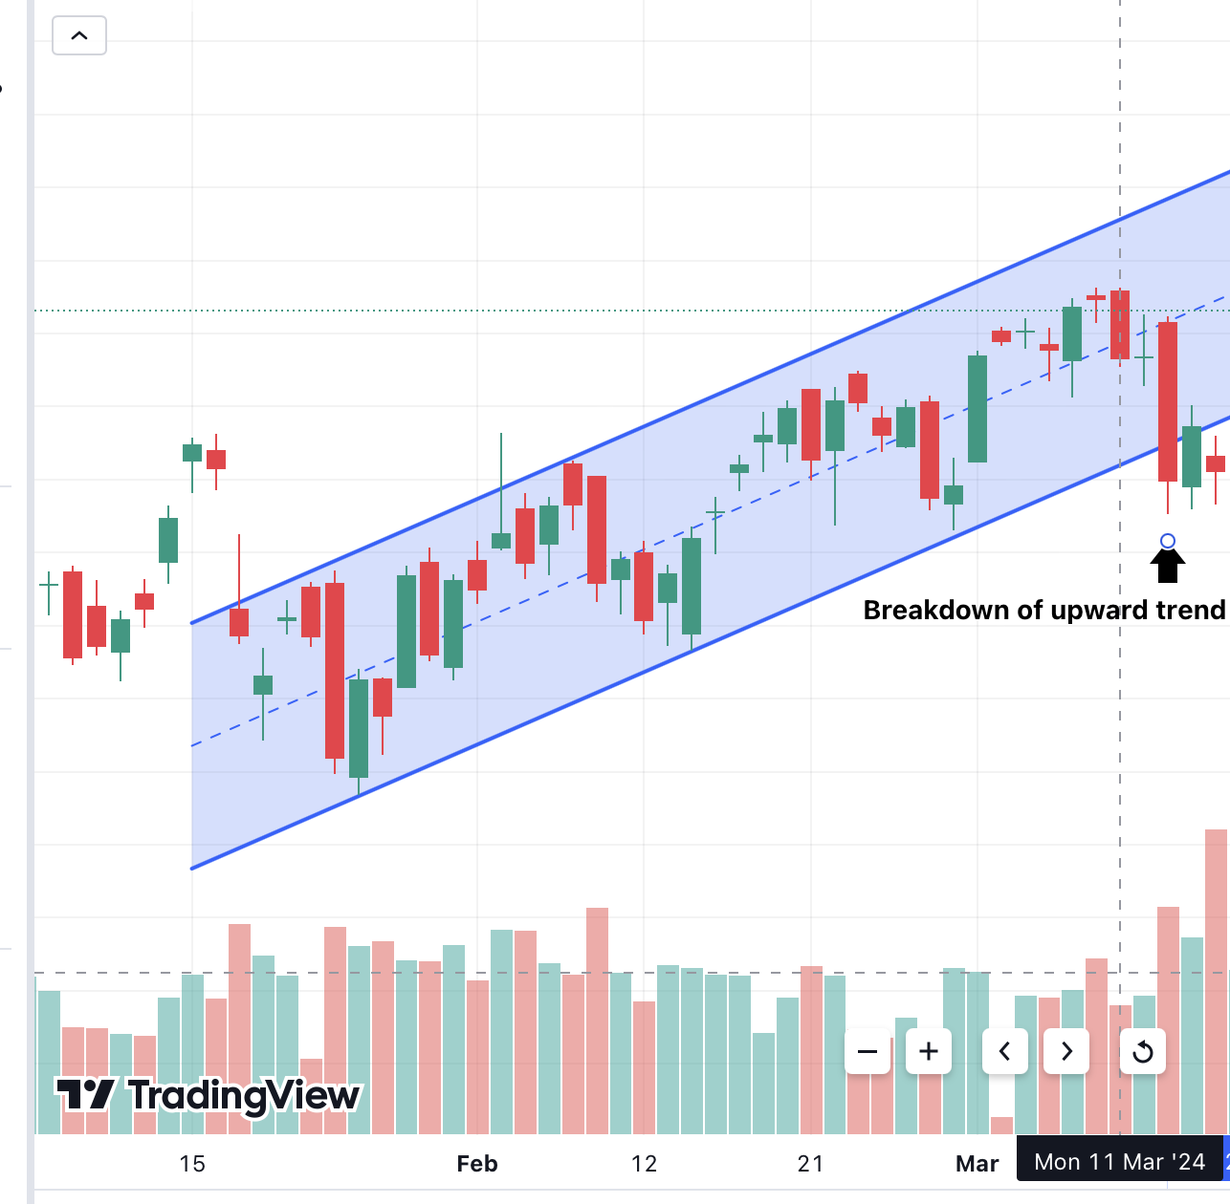

**This candlestick chart shows a breakdown of an upward trend**, also known as a channel breakdown. This is a bearish signal that suggests the price could be headed lower.

* The two upward-sloping lines represent the channel of the uptrend.
* The price breaks below the lower trendline of the channel, indicating a potential reversal of the trend.

**1.3. Strategy Used**

We used 2 strategies, with the following actions -

1. Iron Condor strategies, as we believe that the market will move sideways and will not be highly volatile. Taking this position will cater to the condition.
2. Bear Spread with Put - We believe, higher probability of market movement is towards the downside, hence to increase the downside gain, we take up this strategy as well.

|  |  |
| --- | --- |
| **Iron Condor** | **Bear Spread with Put** |
| Put Option Buy of Strike 21,900 Rs. | Put Option Sell of Strike 21,950 Rs. |
| Put Option Sell of Strike 22,200 Rs. | Put Option Buy of Strike 22,050 Rs. |
| Call Option Sell of Strike 22,400 Rs. |  |
| Call Option Buy of Strike 22,700 Rs. |  |

Payoff Chart for the Combined Strategy -

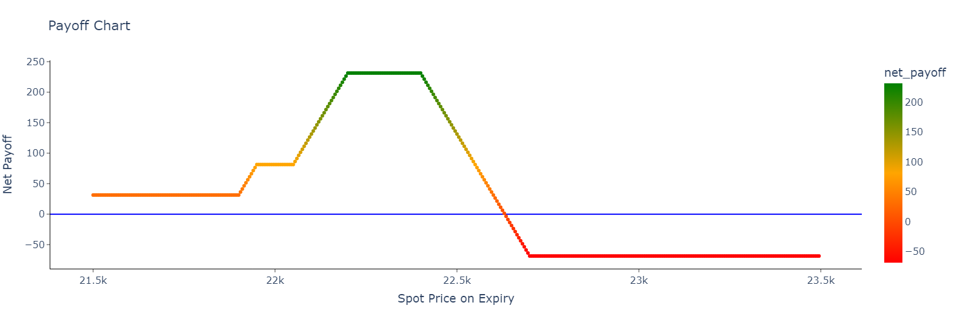

Note: The payoff table is present in the excel link provided below

<https://docs.google.com/spreadsheets/d/10wJNX2v0K8dn_dbN1q0cuK9JXiNA0ihZ4q0OjWDdYxI/edit?usp=sharing>

The preparation of daily P&L and other calculations are done with Python code - link for the same is provided here.

<https://colab.research.google.com/drive/1XpEZ9DoKaOHfifcqvOGFShS3D6aHigza?usp=sharing>

Option Chain Data Source (NSE India) -

<https://www.nseindia.com/report-detail/fo_eq_security>

**Chapter 2**

**Daily Tracking P&L and Strategy Evaluation**

Assumptions -

* We bought the option based on the underlying prices of 11 March 2024.
* Daily P&L is calculated on the daily closing prices.
* Final day P&L is also calculated on the closing price of the option (delivery is not taken).
* Number of contracts is calculated as:

___________________________1,000,000____________________________

(Sum of Prices of the Options Bought * Lot Size) + (Underlying value when options were bought * Lot Size * Margin % * Number of options sold)

* Margin blocked for the options entered into the short position has been calculated as:
  + Underlying price * Margin % * Lot size
* The table below lists the values pertaining to the assumptions

|  |  |
| --- | --- |
| **Underlying Value of NIFTY on first day (11th Mar)** | 22,332.65 |
| **Investment Amount** | 1,000,000 |
| **Number of Contracts** | 3 |
| **Lot Size** | 50 |
| **Margin Percent for Selling Options** | 9.00% |
| **Capital Deployed** | 955,682.33 |
| **Capital Unused** | 44,317.67 |

The daily P&L has been prepared without considering the number of contracts and lot size for ease of understanding.

|  |  |  |  |  |  |  |  |  |
| --- | --- | --- | --- | --- | --- | --- | --- | --- |
| **Date** | **CE Sell 22400** | **CE Buy 22700** | **PE Sell 22200** | **PE Sell 21950** | **PE Buy 21900** | **PE Buy 22050** | **Daily P&L** | **Action** |
| **11-Mar-2024** | 375.2 | 182.9 | 121 | 76.55 | 63.55 | 94.95 | **0** | Bought at Opening |
| **11-Mar-2024** | 267.35 | 131.3 | 164.1 | 96.75 | 87.55 | 120.45 | **42.45** |  |
| **12-Mar-2024** | 264.65 | 124.9 | 142.7 | 80.5 | 72.15 | 101.55 | **-0.35** |  |
| **13-Mar-2024** | 119.65 | 50.5 | 298.7 | 182.8 | 165.35 | 227.55 | **31.5** |  |
| **14-Mar-2024** | 154.75 | 57 | 189.25 | 106.45 | 93.15 | 133.4 | **-9.15** |  |
| **15-Mar-2024** | 100.45 | 32.8 | 241.7 | 135.35 | 120 | 173.9 | **16.1** |  |
| **18-Mar-2024** | 85.7 | 24.75 | 229.7 | 122.7 | 108 | 159.45 | **4.9** |  |
| **19-Mar-2024** | 31.2 | 8.85 | 379.35 | 217.1 | 191.5 | 274.85 | **-6.55** |  |
| **20-Mar-2024** | 19.8 | 4.4 | 340.25 | 180.4 | 157.6 | 236.95 | **10.95** |  |
| **21-Mar-2024** | 28.5 | 3.75 | 180 | 71.7 | 59.1 | 104.9 | **29.05** |  |
| **22-Mar-2024** | 28.2 | 2.2 | 132.2 | 49.3 | 40.35 | 74.45 | **19.75** |  |
| **26-Mar-2024** | 6.25 | 1.05 | 154.5 | 47.6 | 36.5 | 77.8 | **-0.3** |  |
| **27-Mar-2024** | 2.85 | 0.4 | 77.1 | 9.95 | 6.3 | 23 | **32.8** |  |
| **28-Mar-2024** | 8.9 | 0.15 | 3.3 | 0.55 | 0.3 | 0.95 | **48.85** | Sold at Closing |

The final result after considering lot size and no of contracts is provided in the below table:

|  |  |
| --- | --- |
| **Particulars** | **Rs** |
| **Total P&L** | 33,000.00 |
| **Percentage P&L (18 days)** | 3.45% |
| **Percentage Gain (Annualised)** | 48.34% |
| **Number of Loss Days** | 4 |
| **Number of Win Days** | 9 |
| **Max Profit in 1 day** | 7,327.50 |
| **Max Loss in 1 day** | -1,372.50 |
| **Average P&L in 1 day** | 2,357.14 |
| **Standard Deviation 1 day** | 2,810.31 |

**Chapter 3**

**NSE Website Option Chain Screenshots**

Call Option of strike Rs. 22,400 (Used for the Iron Condor)

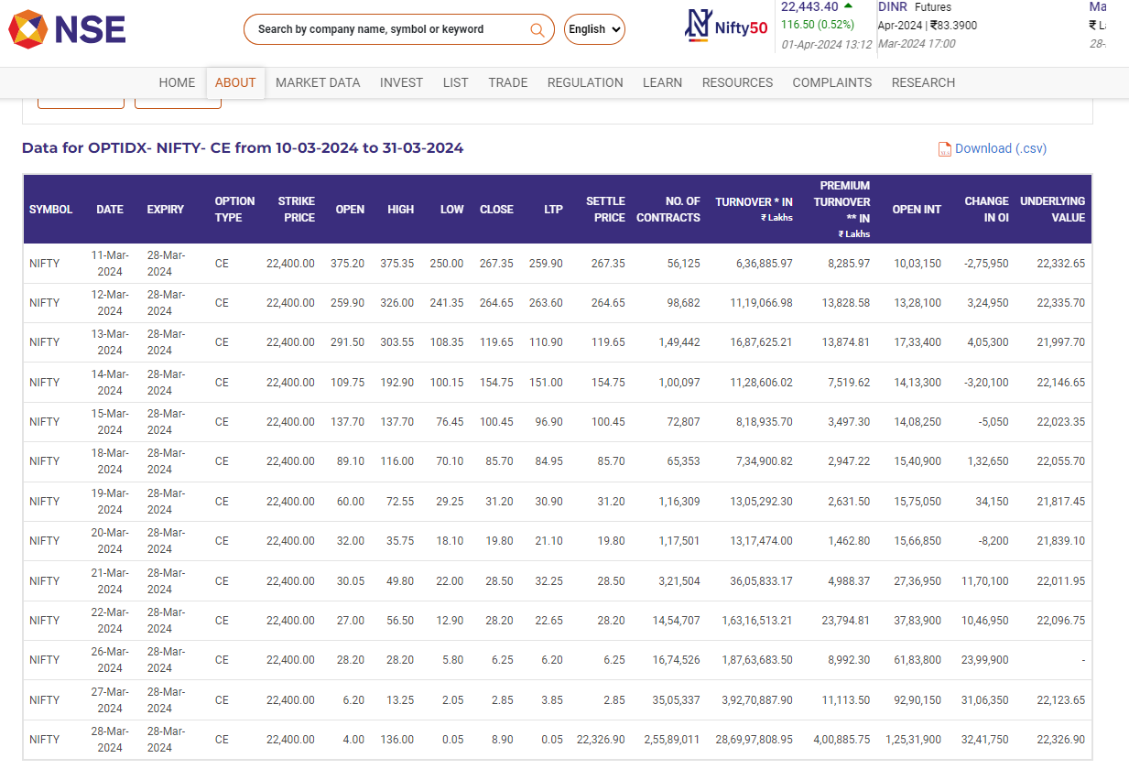

Call Option of strike Rs. 22,700 (Used for the Iron Condor)

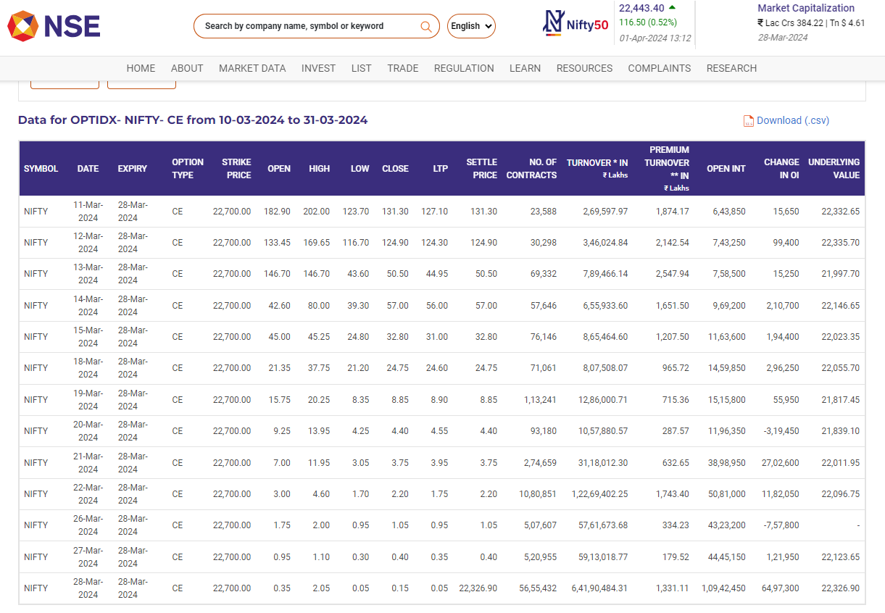

Put Option of strike Rs. 22,200 (Used for the Iron Condor)

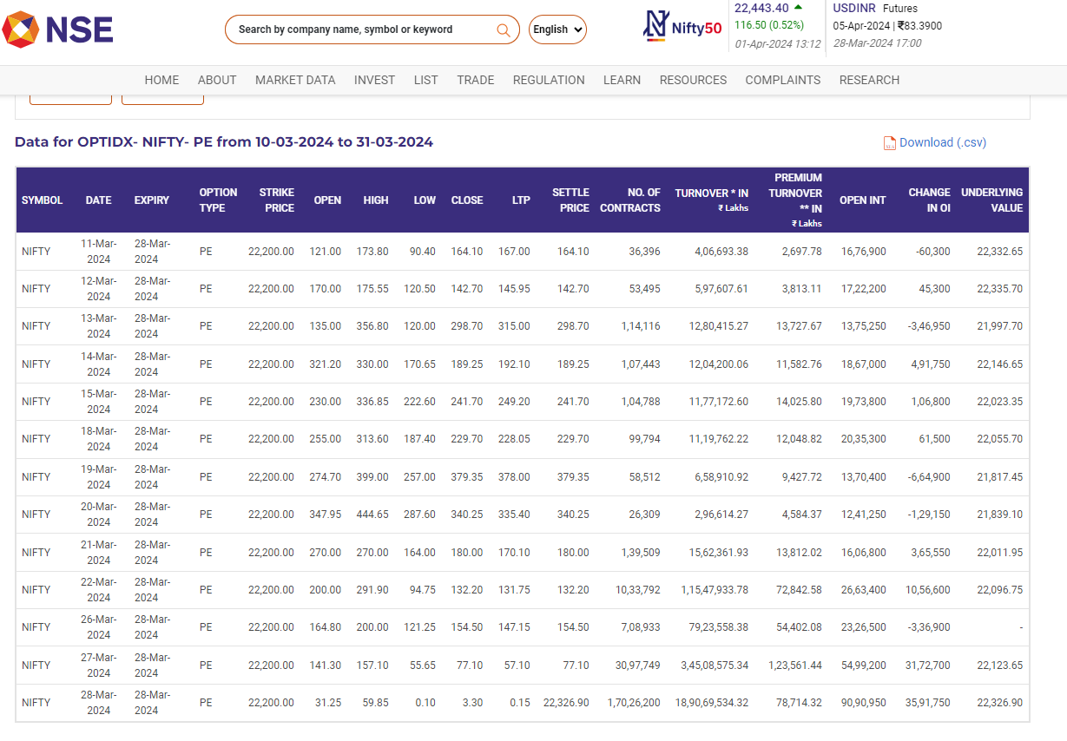

Put Option of strike Rs. 21,900 (Used for the Iron Condor)

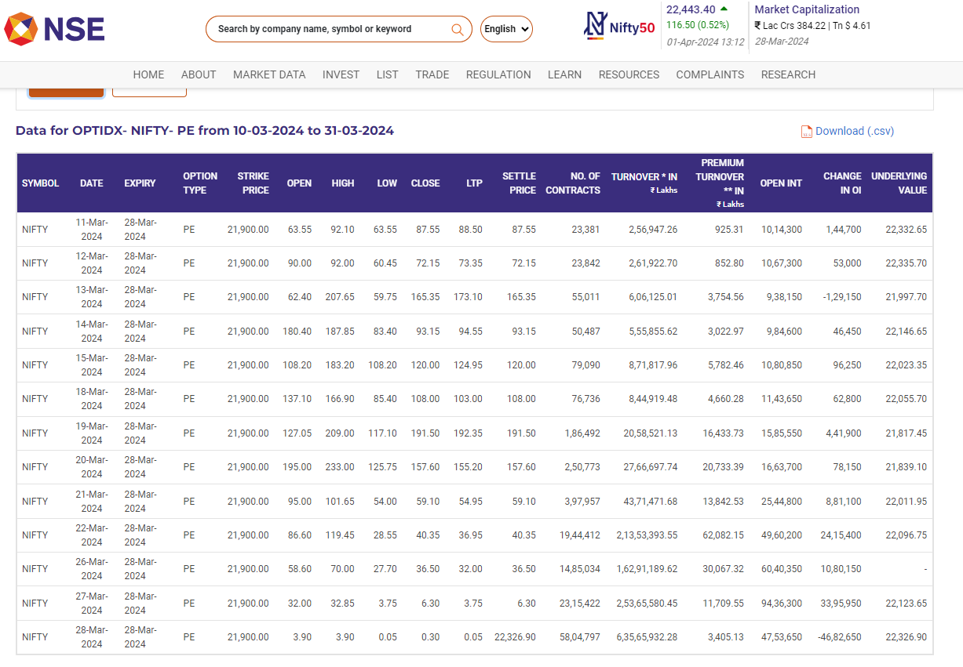

Put Option of strike Rs. 21,950 (Used for the Bear Spread using Put)

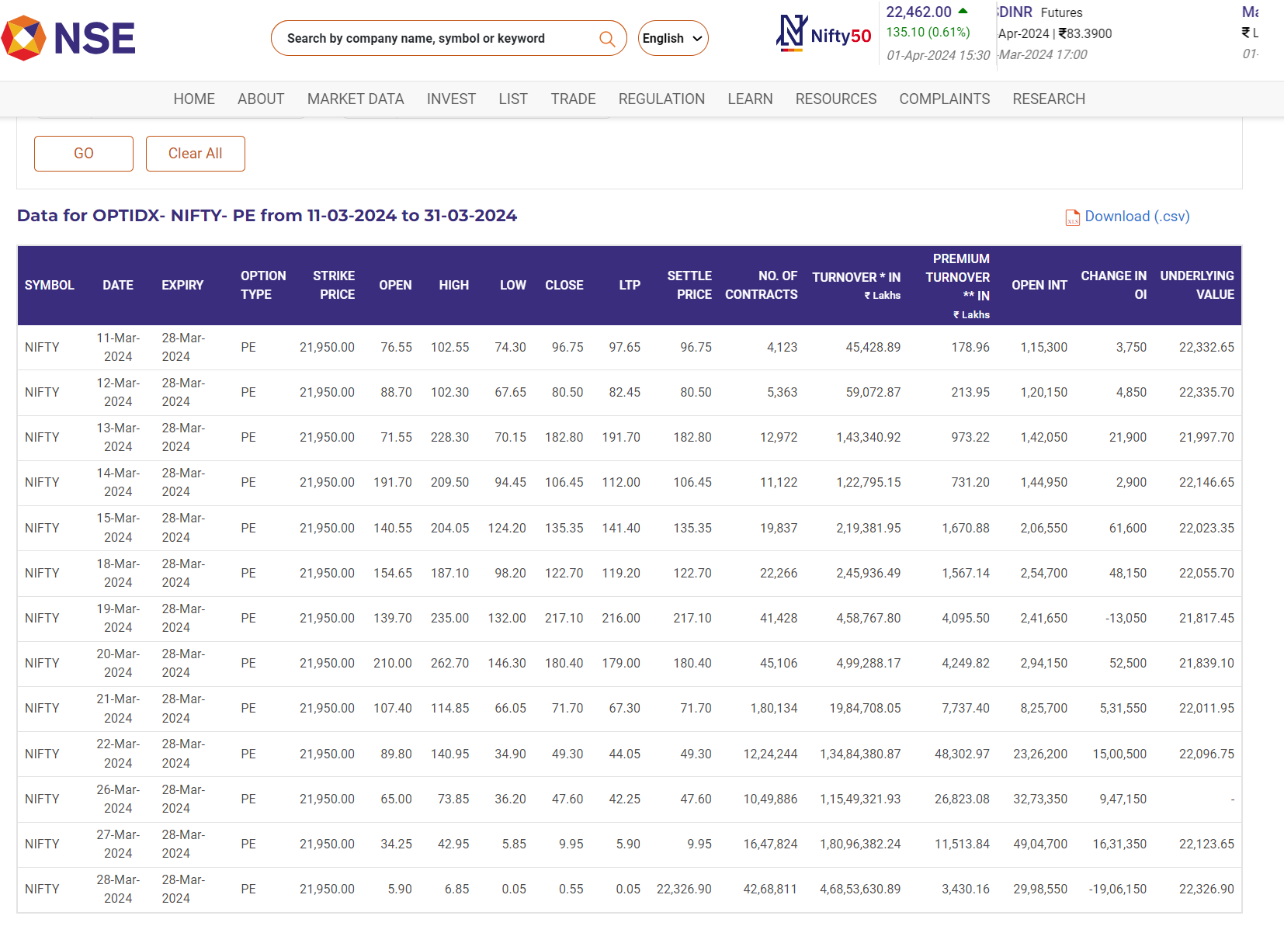

Put Option of strike Rs. 22,050 (Used for the Bear Spread using Put)

